CS 255 System Design Document
Blake Moore

UML Diagrams

UML Use Case Diagram
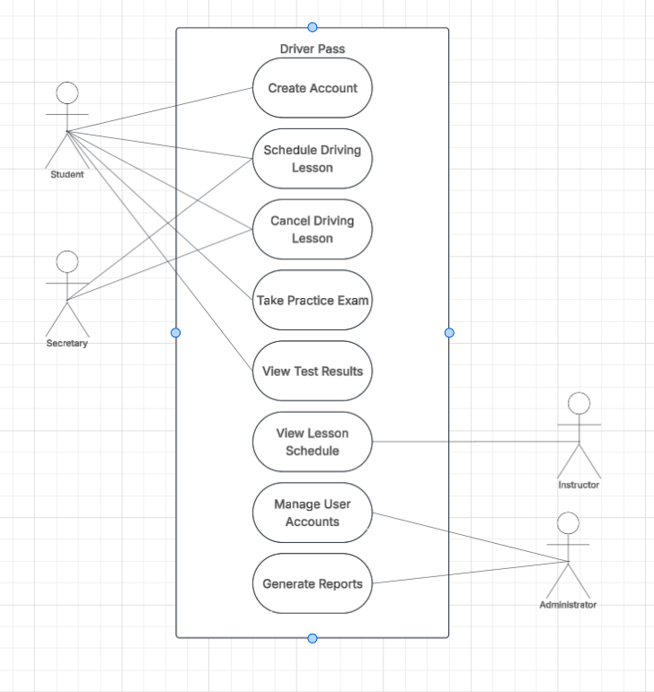

UML Activity Diagrams
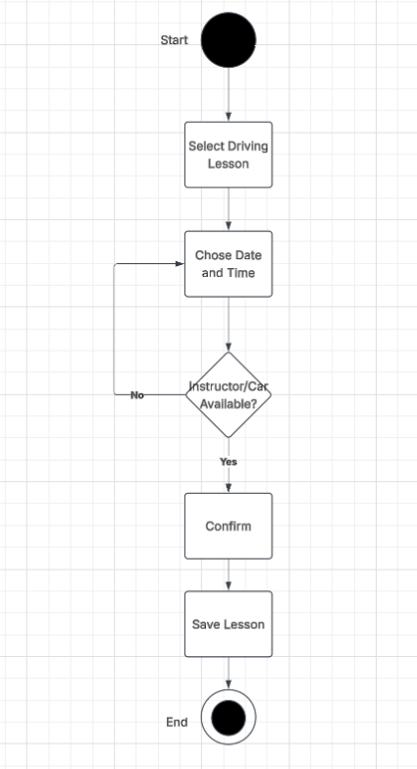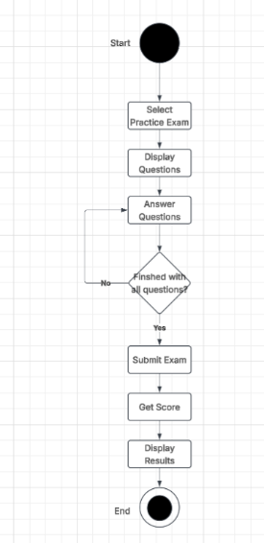

UML Sequence Diagram
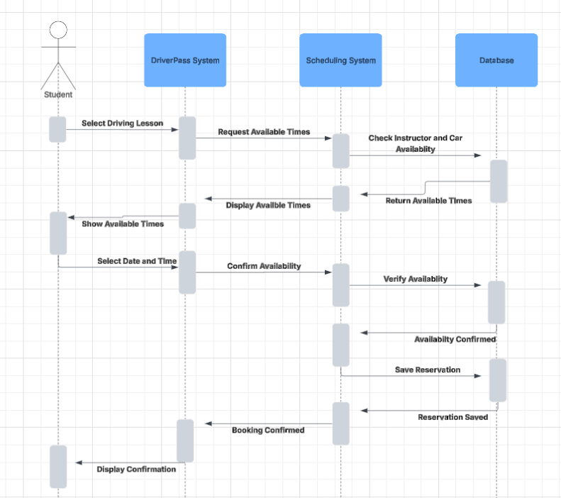

UML Class Diagram
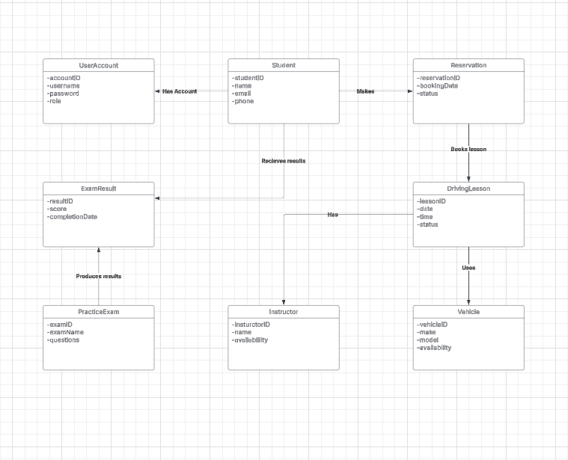

Technical Requirements
Hardware Requirements
- DriverPass needs computers or mobile devices that have access to the internet for students and employees.
- System will use cloud servers to store and process all information.
- Instructors and employees will need devices to access schedules and information of customers.

Software Requirements
- System will be web based and accessed through browsers on Windows, mac, iOS, and Android.
- A database will store accounts of customers, lessons, schedules, vehicles, and practice exam results.
- The system will have account management, lesson scheduling, and practice exams.
- The Software will support updates when the DMV rules and requirements change.

Tools and Infrastructure
- Cloud hosting will allow students and employees to use system from different locations.
- A database management system will maintain DriverPass info.
- Users will be required to log in with username and password.
- Different levels of access will set what students, instructors, secretaries, and admins can do.
- System will maintain activity logs to keep track of reservations and cancelations.
- Regular backups will protect info.
- Reports will be downloadable.

Security Requirements
- Passwords will be secure using password hashing.
- Customer info will be protected using encrypted connections.
- Admins will be able to reset passwords and disable accounts.
- System will prevent double booking of instructors and vehicles.
- Reservation changes will be recorded.

